RecRock – My Creative Brain

Participant Enrolment Form

1. Your Details

First name: | Surname:

Date of birth: | Age: | Male / female / non-binary

Home address:
Postcode

Contact Number | Email address

Are you currently enrolled in any form of education, training or employment? | Y/N

2. Which course(s) would you like to attend? Please tick as necessary.

Course name | Do you wish to attend this course? (please tick)
Art
Creative Writing
Music Skills
Song Writing
Life Hacks for Creative People
2. Course Attendance:

We would like to know why you want to attend the course so that we can tailor the classes specifically to you and the other participants.

We would also like to know if you might find it difficult to attend sometimes. If we are aware of any issues or difficulties you might experience beforehand, we can work to make the course as comfortable and accessible for you as possible.

What are the reasons you would like to attend the course?

e.g.

- would like to build your confidence

- would like to get better at a particular creative skill

- would like to improve your mental health and wellbeing

Are there any reasons that you might find it difficult to attend the course sometimes? (e.g. caring responsibilities or mental/physical wellness)?

3. Your skills and aspirations:

Please list the main hobbies and interests that interest you as well as the skills you would like to improve.

Internet connection

Do you have any difficulties connecting to the internet from home? Please give details below:

Contact preferences

Are you happy for RecRock to contact you directly using your contact details submitted on this referral form? | Y/N

Thank you

Please return form to cat@recrock.co.uk

Or contact us on 02921 202980 - 07879856430 to discuss the referral in more detail

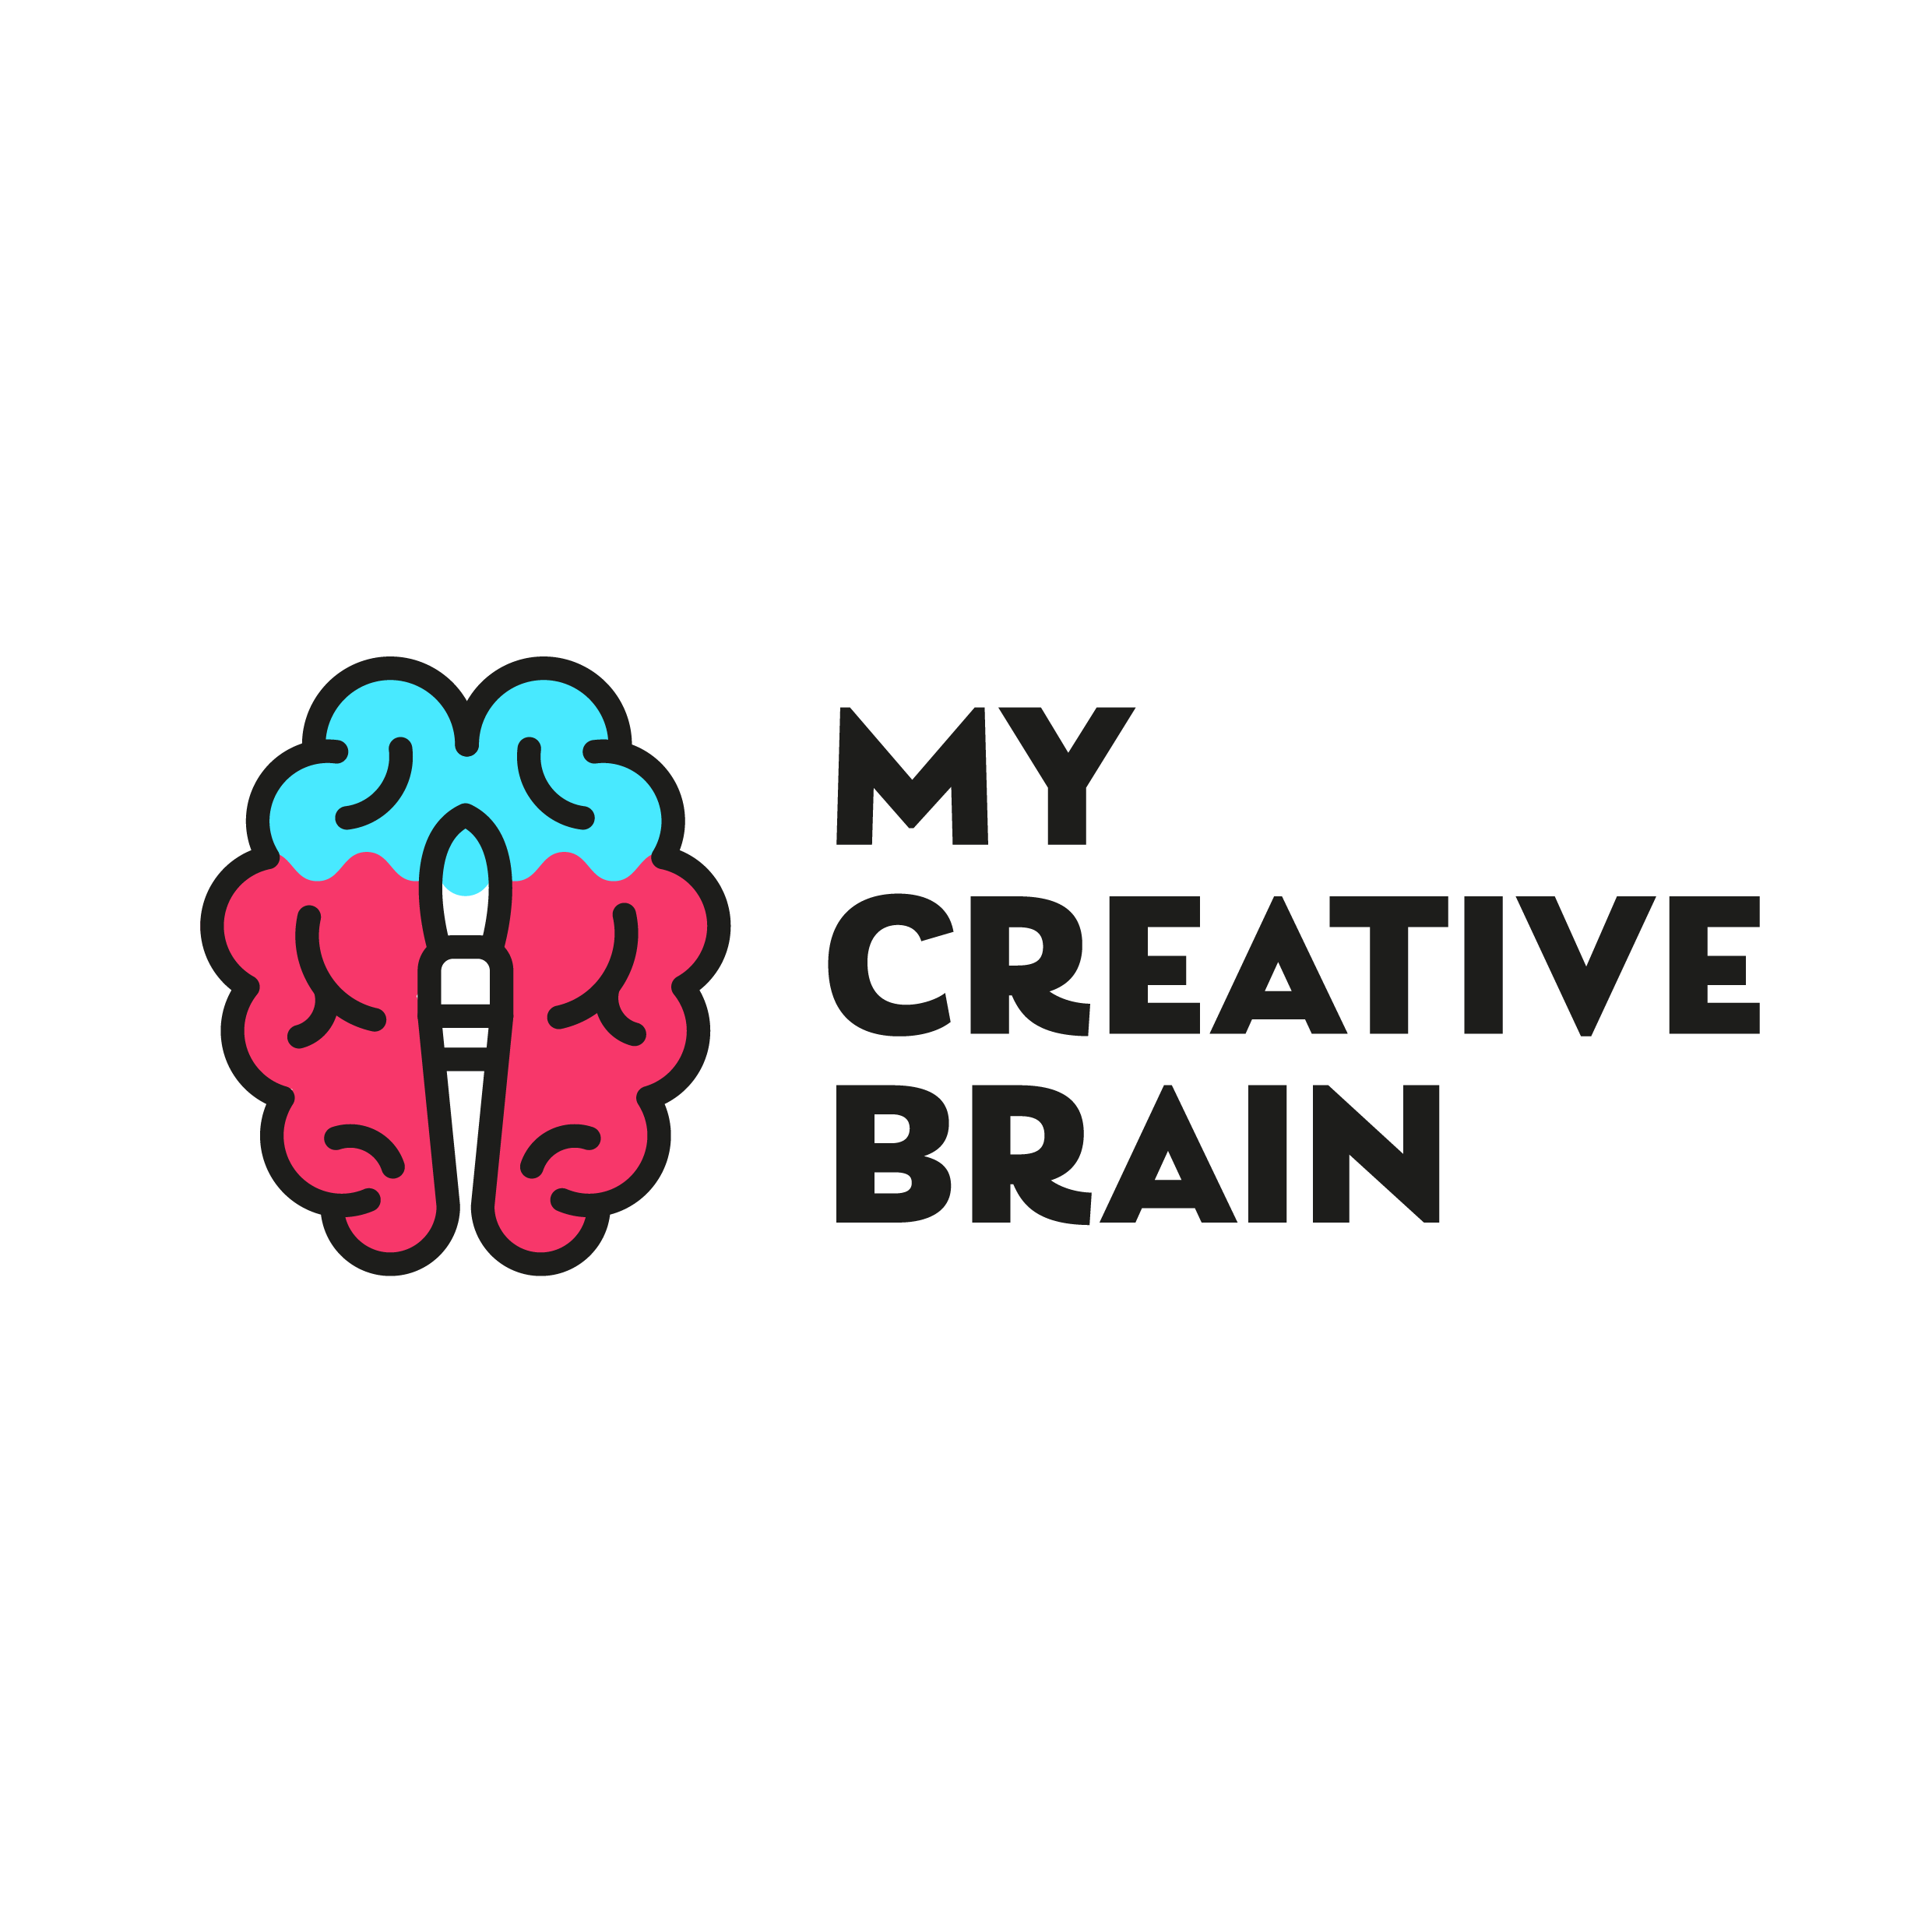
My Creative Brain has received support from the Cwm a Mynydd Rural Development Programme through the Welsh Government’s Rural Communities – Rural Development Programme 2014-2020 funded by the Welsh Government and the European Agricultural Fund for Rural Development.

Cwm a Mynydd is delivered by Caerphilly County Borough Council on behalf of the Cwm a Mynydd Local Action Group. For more information contact rdp@caerphilly.gov.uk or 01443 838632
